Demo Script for Comms SOR
myWorld 5.2.1.0.alpha8

Contents
DATA 1
VIEW AND TRACE 1
SCENARIO: EXTEND NETWORK 2
SCENARIO: OTDR TRACE 4
SCENARIO: EXTEND NETWORK USING CUSTOM TOOLS 4
SCENARIO: CONFLICT RESOLUTION 5
OTHER 5

DATA
- Go to Home
- Show structure network legend
- Show manholes, cabinets, routes, hub
- Select route + show cables
- Select structure + show equipment
- Pan to pole 006. Show poles and aerial routes
- Explain data captured from Google
- Enable street view
- Show manhole and pole
- Close streetview

VIEW AND TRACE
- Show cables layer
- Show equipment layer
- Show search for splitters
- Select wall box
- Do upstream trace
- Show trace results
- Open patch panel
- Do downstream trace on port 6
- Show splitter and drops

SCENARIO: EXTEND NETWORK

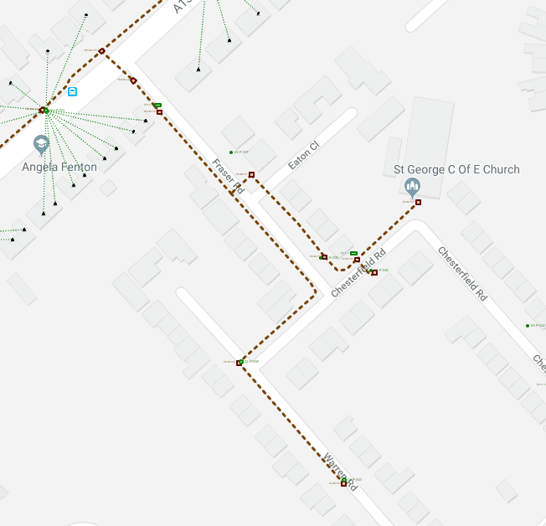
- Pan to Kendal way
- Show layers OS buildings + Addresses
- Turn off buildings and addresses
DESIGN
- Turn on designs layer
- Show that there are designs in system
- Open one, show content
- Close it
- Create a design .. and set boundary to work area
- Open design
- Change design state to 'Designing' (enables structure mode etc)

STRUCTURES
- Show insert menu. Note can insert
- Start structure mode
- Add underground routes
- Note snapping, undo
- Note: CTRL to disable snapping
- Add manhole + set orientation
- Set attributes and save to palette
- Add more manholes
- Add cabinet
- Show path to EDA .. or trace out 250m
CABLES
- Start equipment mode
- Add cables
EQUIPMENT
- Select a manhole
- Show palette content has changes
- Add a splice closure
- Add a splitter
- Add a splitter
- Ser a spec

- Do some more

- Show 'Add to Palette'

LAYERS
- Show cables
- Show equipment layer

CONNECT EQUIPMENT

ADD CONDUITS
- Route conduit
- Move cables into conduit

ADJUST
- Turn on Google sat
- Move objects

SCENARIO: BUILD BLOWN_FIBER CONNECTION

Explain two sorts of conduits (simple and continuous)

SHOW CONTINUOUS CONDUITS

ROUTE CABLE

CUT AND JOIN CONDUITS

MOVE CABLE INTO CONDUIT

SCENARIO: OTDR TRACE

- Select a wallbox
- Trace upstream
- Select patch panel port
- Trace downstream to distance

SCENARIO: EXTEND NETWORK USING CUSTOM TOOLS
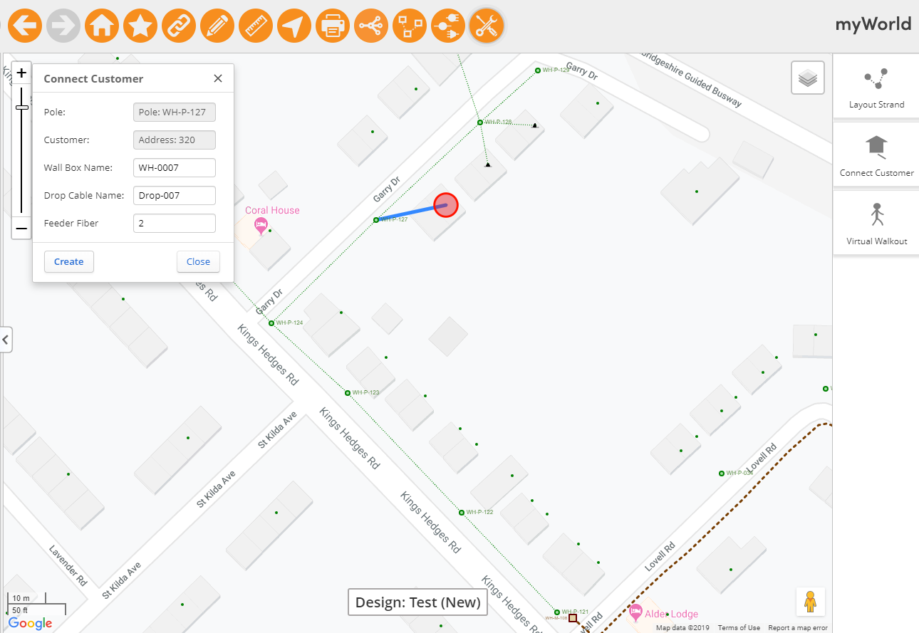

Setup
- Create a design around Kings Hedges Rd / Garry Dr
- Open it
- Activate tools

Layout out strand
- Add poles + routes along Kings Hedges Rd
- Note that pole name updates
- Note that strand colour changes when limit exceeded
- Click restart
- Select pole at junction with Garry Rd
- Add poles + routes along Garry rd
- Close tool

Add cable
- Open equipment palette
- Clear selection
- Add cable from KH start pole to GR end pole

Connect Customers
- Turn on customers layer
- Open customer connection tool
- Select a GR pole
- Select a nearby address
- Hit create
- Show splitter created add connected IN and OUT#1
- Connect 3 more customers. Show OUT ports all connected
- Add 1 more customer. Show new splitter
- Trace upstream from a customer ONT#1. Show goes to KH pole
- Close tool

Virtual Walkout
- Open streetview (drag pegman onto map)
- Start VW tool
- Reverse path
- Hit play

SCENARIO: CONFLICT RESOLUTION
Log in as Admin (to permit changes direct to master)
Setup:
- Add a wallbox location near WH-P-004
- Open a design
- Add aerial route, ONT
- Add a cable from manhole to wallbox and connect at both ends
- Close design

Create conflict (simulate data corrections from separate survey):
- Move manhole, pole and wallbox

Resolve conflict:
- Open design. Things show broken on map
- Check for conflicts. Various issues listed
- Try to post. No permitted
- Hit merge. Show things changed
- Refresh. Data now looks OK
- Check for conflicts. None found
- Post. Posts OK

OTHER
- Attributes configurable
- Equipment configurable
- Show cabinet photos

END

